Press Release:
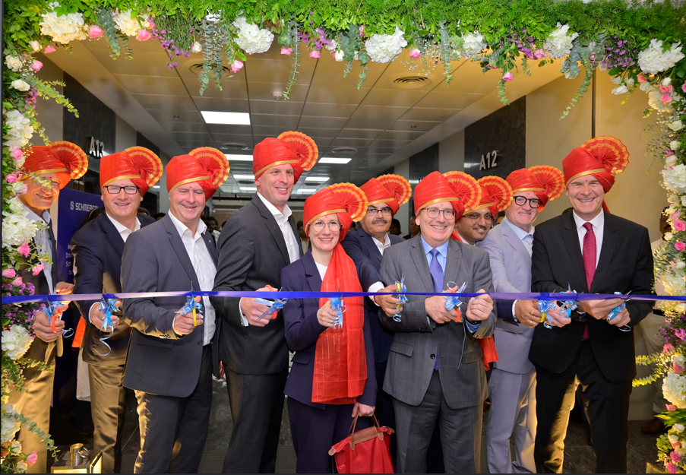
Photo 01 - Ribbon cutting ceremony from left Mr. Rogerio Baldauf - Managing Director (Schmersal Brazil), Mr. Gary Ferguson - Managing Director (Schmersal USA), Mr. Uwe Seeger - Director (Schmersal Asia & Middle East, Mr. Michael Ambros - Managing Director (Schmersal Group), Dr Anna Dahlem – Head of People and Culture (Schmersal Group), Mr. Ramji Singh - Managing Director (Schmersal India), Mr. Christoph Hallier - International Relations and Diplomacy, Mr. Jayadev Devadas – Vice President (Schmersal Global Competence Center), Mr. Giovanni Lucido – Managing Director (Schmersal Italy & Switzerland), Mr. Jan Noether - Director General, Indo-German Chamber of Commerce
Schmersal Global Competence Center (SGCC) Expands Operations with new Facility and Launches an Innovative Product Portfolio
July 01, 2026, Pune, India – Schmersal Group is pleased to announce the expansion of its operations with the inauguration of a new, state-of-the-art office facility spanning within 25,000 sq feet campus along with the opening of Product Experience Center (Marketing Gallery) in Wing A, Office no 603, AP4 Tech Park, Sr No 1344, Wagholi, Besides Grant Road, Pune-Nagar Road, Pune, 412207.
We also take this opportunity to launch six new “Make in India” Products, further expanding our portfolio of machine safety systems and solutions. These new products strengthen our offerings in safety, automation, and industrial efficiency while meeting our customers' evolving requirements across a wide range of applications.
This strategic expansion underscores Schmersal’s ongoing commitment to innovation, engineering excellence, and delivering cutting-edge safety software and solutions to global markets with digital solution as an added value to customers. The new facility significantly enhances the company’s operational capacity, enabling it to support growing customer demand and accelerate the development and deployment of next-generation technologies.
Strengthening Global Capabilities
The newly inaugurated office space has been designed to foster collaboration, innovation, and agility. The expansion will further strengthen SGCC’s position as a high-impact hub for engineering, product development, and digital transformation initiatives within the global Schmersal Group network.
“This expansion marks an important milestone in our journey. We have decided to relocate to our own and bigger facility in Pune. It will explore to strengthen its global engineering, digital solution, innovation and automation capabilities in our current man and machine safety solutions and service as an added value to align and upgrade to market and customer offerings.” said Mr. Ramji Singh, Managing Director. “The new facility not only reflects our growth ambitions but also reinforces our commitment to delivering world-class safety solutions. It provides an environment where innovation thrives and talent can achieve its full potential.”
Along with our new office we are inaugurating product experience center and we are also taking this opportunity to introduce six new products from our Indian manufacturing operations. 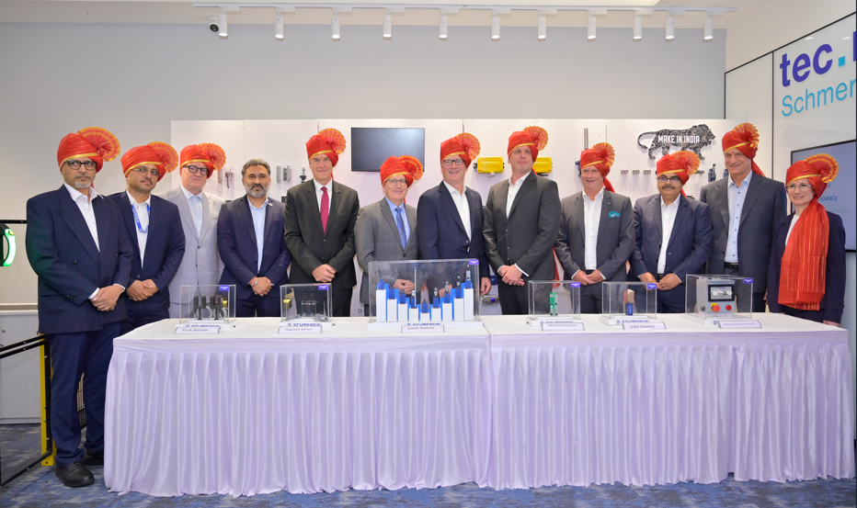
Photo 02 - Product launch, from left Mr. Dnyaneshwar Pangarkar - Vice President (Schmersal India), Mr. Jayadev Devadas – Vice President (Schmersal Global Competence Center), Mr. Giovanni Lucido – Managing Director (Schmersal Italy & Switzerland), Mr. Kalpesh Saraf, Head - Indo German Chamber of Commerce, Mr. Jan Noether - Director General, Indo-German Chamber of Commerce, Mr. Christoph Hallier - International Relations and Diplomacy, Mr. Gary Ferguson - Managing Director (Schmersal USA), Mr. Michael Ambros - Managing Director (Schmersal Group), Mr. Uwe Seeger - Director (Schmersal Asia & Middle East), Mr. Ramji Singh - Managing Director (Schmersal India), Mr. Rogerio Baldauf - Managing Director (Schmersal Brazil), Dr Anna Dahlem – Head of People and Culture (Schmersal Group)
In parallel with the facility expansion, the Schmersal Group also unveiled a new range of innovative products designed to meet the evolving needs of various industries. These products, developed and manufactured in India, focus on enhancing industrial safety, improving process efficiency, and enabling smarter automation across sectors including manufacturing, logistics, vertical transportation, automotive, warehousing, and infrastructure.
The newly launched portfolio features:
Safety Field Box Port Extender – Enhances system connectivity and scalability by enabling seamless integration of field components across complex industrial setups.
Magnetic Switch – A cost-efficient, European-standard-compliant solution offering reliable position monitoring with consistent performance and durability, especially suited for the elevator segment.
Fork Sensor – Infrared-based sensing solution designed for precise object detection in high-speed, high-accuracy industrial applications.
New Safety Limit Switch Series – Upgraded, robust, and versatile switches engineered to meet stringent safety requirements across diverse operating conditions, tailored for the Indian market.
Overspeed Governor Limit Switch – Designed to detect when systems such as elevators exceed safe operational speed, ensuring enhanced safety and immediate response.
Multi-level Parking Control System – Enables authorized users to control vehicle movement across levels using key-based operation, supporting efficient and secure multiparking.
These solutions align with Schmersal’s vision of turning workplaces into safer places.
The Product Experience Center showcases the Schmersal Group's comprehensive safety solutions and demonstrates machine safety compliance expertise provided by tec.nicum.
Visitors can experience:
- Safety solutions for people and machines
- Machine guarding, interlocking, and access control systems
- Comprehensive machine safety solutions based on six key pillars, complemented by software and engineering services
- The transformation of industrial machine applications into safer, smarter, and more digital solutions through Software as a Service (SaaS), in collaboration with tec.nicum and the Schmersal Global Competence Center (SGCC)
Driving Innovation and Talent Growth
The expanded facility will also play a critical role in fostering talent development and supporting cross-functional collaboration. With enhanced infrastructure and increased capacity, the SGCC aims to attract top engineering and technology talent while strengthening partnerships with global stakeholders.
The occasion also marks another significant milestone: 13 years of Schmersal's manufacturing operations in India, underscoring the company's long-standing commitment to the Indian market and its continued investment in local manufacturing and innovation.

About Schmersal
The Schmersal Group was founded in 1945 in Wuppertal, Germany, and is represented by eight manufacturing sites on four continents with its own companies and sales partners in more than 60 nations. The Schmersal Group employs some 2000+ people worldwide.
Schmersal India started its operation as a 100% Subsidiary of Schmersal Group in the year 2007 and set up manufacturing plant in the year 2013 at MIDC Ranjangaon as well as 100% export unit to manufacture certain product for global market. The company has a strength of around 200 employees and more than 30 channel partners across India.
The Schmersal Global Competence Center (SGCC) is a 100% subsidiary of Schmersal Group. The process of setting it up as a legal entity was initiated in February 2021 & it becomes operation from 1st January 2022 at Pune, Maharashtra with employee strength of nearly 60 nos. It is specialized engineering and IT hub for the Schmersal Group globally. it serves as a global resource pool for custom application development, Microsoft technologies, SAP, IT Infrastructure, embedded development, and IoT, distinct from Schmersal's manufacturing.
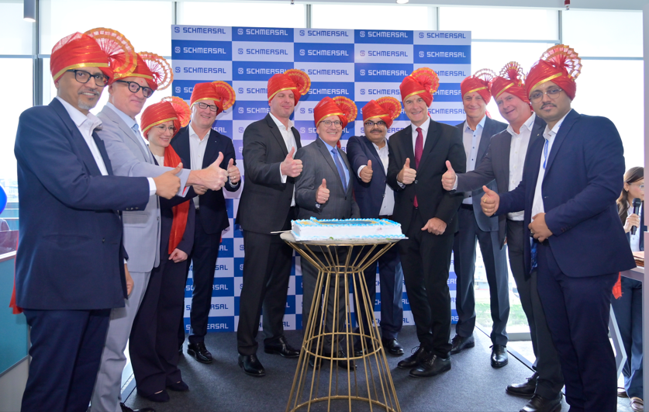
Photo 03: Celebration with the team, from left Mr Dnyaneshwar Pangarkar - Vice President (Schmersal India), Mr Giovanni Lucido – Managing Director (Schmersal Italy & Switzerland), Dr Anna Dahlem – Head of People and Culture (Schmersal Group), Mr Gary Ferguson - Managing Director (Schmersal USA), Mr. Michael Ambros - Managing Director (Schmersal Group), Mr. Christoph Hallier - International Relations and Diplomacy, Mr. Ramji Singh - Managing Director (Schmersal India), Mr. Jan Noether - Director General, Indo-German Chamber of Commerce, Mr Rogerio Baldauf - Managing Director (Schmersal Brazil), Mr. Uwe Seeger - Director (Schmersal Asia & Middle East), Mr. Jayadev Devadas – Vice President (Schmersal Global Competence Center)
This new capability center will play a key role in contributing to our long-term strategy, planning and growth with additional skills, resources and infrastructure, and it will leverage India’s strong talent ecosystem to support global operations.

www.schmersal.in
www.schmersal.in/company/schmersal-global-competence-center

Media contact:
Triptishree Saha
tsaha@schmersal.com

